NOTES:

20
Judah Ministries International
Conference 2007
“Committed to the Harvest”

*CONFERENCE OUTLINE

Wednesday, July 25, 2007 – Arrival Day

- 10:00 am Bus Tour

Thursday, July 26, 2007

- 9:00 am Registration Opens
- 10:00 am JMI Choir Rehearsal
- 1:00 pm “Stir Up The Gifts”
- 3:30 pm Usher Drill (For Thursday & Friday)
- 7:30 pm Evening Worship
Speaker: Bishop-Elect John Birmingham

Friday, July 27, 2007 – Day 2

- 7:00 am Early Morning Glory
- 9:00 am Breakfast (Everyone on Their Own)
- 10:30 am “Word From the Sowers”
- 2:00 pm JMI Business Meeting
      - 3:00 pm JMI Choir Rehearsal
- 7:30 pm Evening Worship
Speaker: Bishop Victor Powell
Rhema Word International Ministries, Albany, GA.

Saturday, July 28, 2007 – Day 3

- 7:00 am Early Morning Glory
- 9:00 am Breakfast (Everyone on Their Own)
- 10:30 am Adult Seminar-Pastor Juan Price Youth Events/Seminar
      - 2:00 pm Usher Drill (For Saturday & Sunday)
- 6:00 pm “Youth Explosion”
Speaker: Elder Tracy Boles
New Beginning Full Gospel Baptist Church, Decatur, GA.

Sunday, July 29, 2007 – Day 4

- 10:00 am Christian Learning School,
- 11:30 am Morning Worship
Speaker: Bishop George W. Manigault, II, Presiding Prelate
Consecration & Communion Service - Bishop-Elect John Birmingham

*Program subject to change

1
Judah Ministries International
Conference 2007
“Committed to the Harvest”
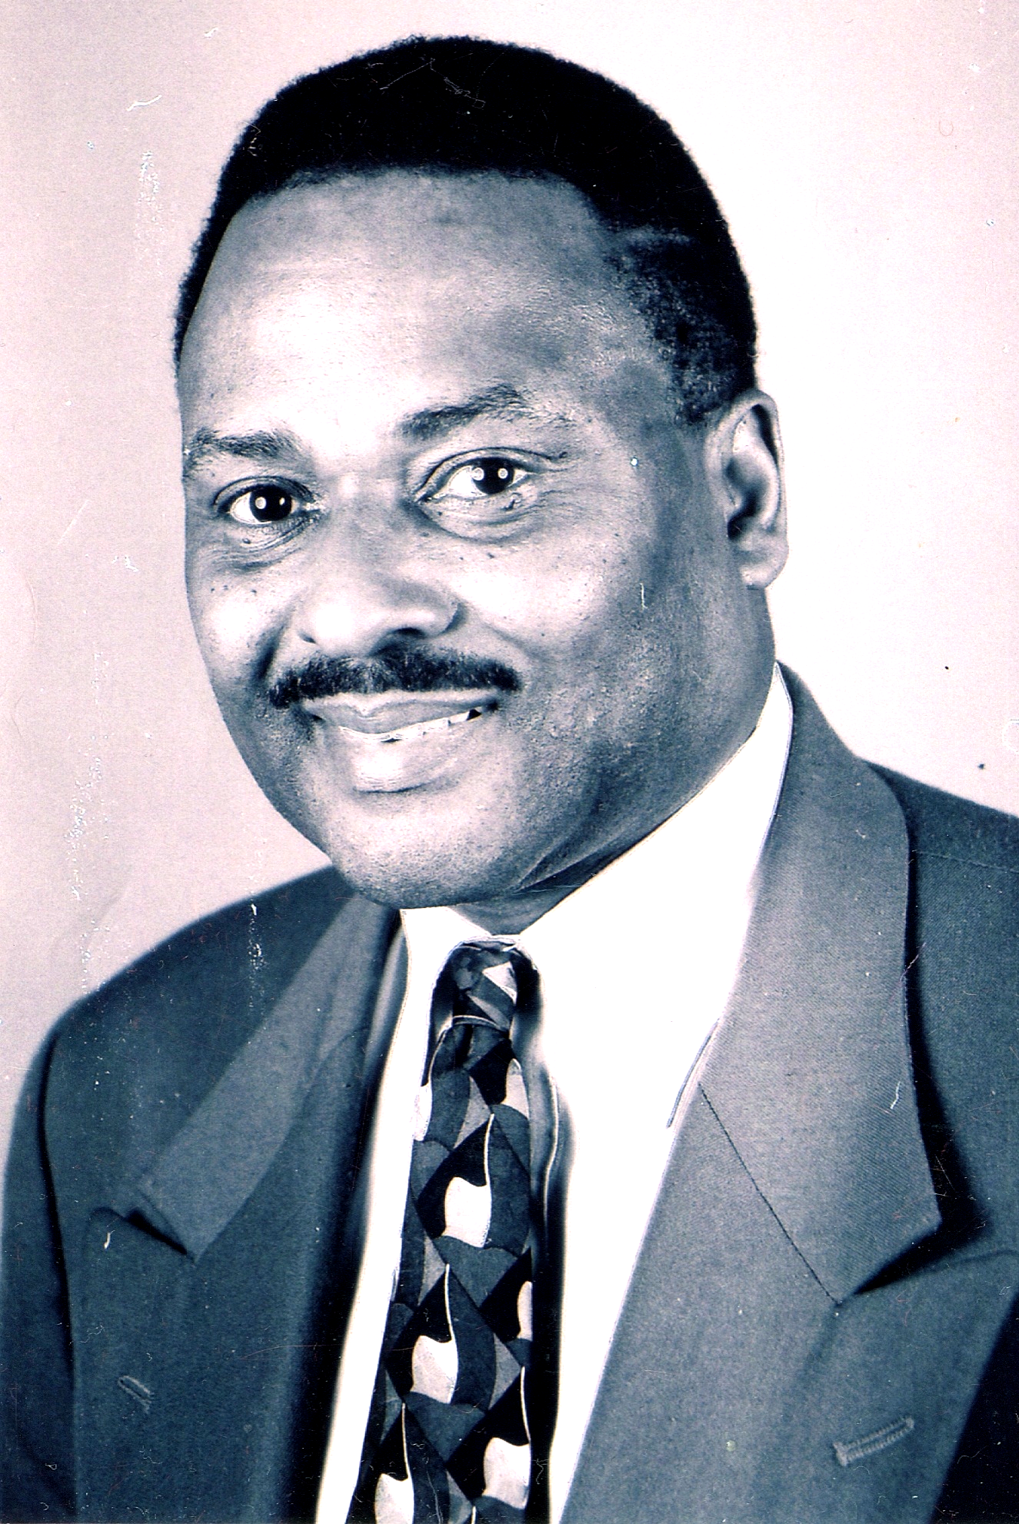

Bishop-elect John D. Birmingham Jr.

Bishop–elect John D. Birmingham Jr. was born in Kansas City, Missouri. He is the eldest of twenty-four children. Educated in the Kansas City (MO) School District, he went on to attend Western Bible Seminary and Faith Bible College. He has a Doctorate degree in Theology and Christian Education, as well as a degree in Christian Counseling. He confessed his faith in Christ Jesus at tem and became a young deacon. Deacon Birmingham accepted his call to the ministry when he was 21 years old under the late Rev. Charles Wheeler III at Westminster Baptist Church. Rev. Birmingham’s first charge was at Second Baptist Church in St. Louis, MO. He served as a pastor in Hugo, OK and is currently the pastor of Victory in Praise Revival Center in Raytown, MO. He is also Chancellor of Harvest Reapers Bible College (FBC) in Raytown, MO. During the 1970s and late 1980s, Bishop–elect Birmingham made an impact in the Kansas City area via The Upper Room Compassionate Ministry. This ministry was located on the North end of Troost Avenue in an area known as the “Red Zone.” This area was infamous for pimps, prostitution, drug pushers, pornography shops, strip bars, and gay establishments. God used Bishop-elect Birmingham to clean up Troost Avenue in a way that local law enforcement could not. The move of God was so overwhelming that the mayor named him Chaplain of Troost. He was also featured on the 700 Club with Pat Robertson. Bishop-elect Birmingham has held revivals and crusades from as far as Jamaica and Haiti to the outskirts of our Southern states. What is dear to his heart, year after year, is helping the community by preaching the Gospel to save souls, feeding the hungry, and clothing the less fortunate. In the late 1970s, he wrote a play entitled Soul Free, which aired on a local television station. He is also the author of several books: Chaplain of the Troost, Young Black Men an Endangered Species, Slipping of the Shepherds and the latest Take it to the Streets. Bishop-elect Birmingham is a true humanitarian of his own kind. He has one son, Kenneth Steele, who is also in the ministry.

2
Judah Ministries International

Member Churches (continued)
Faith Apostolic Church of Jesus Christ | Greater Faith Worship Center Campus
Pastor Patricia Myricks | Bishop F. J. Wilson
5 Barclay Court | Pastor Ruth e Wilson
Rochester, NY 14612 | 120 Safford Street
 | P.O. Box 365684
 | Hyde Park, MA 02136
 | Tel: 617-361-5479
 | gfwcc@verizon.net
Holy Tabernacle Church #2 | Holy Tabernacle Church of Brockton
Pastor Naomi Witherow | Bishop G. Warren Manigault II
8221 Old Cleveland Pike | Pastor Cathy McCray-Manigault
Ooltewah, TN 37363 | 861 Main Street
Tel: 423-892-8441 | Brockton, MA 02301
Nwitherow@aol.com | Tel: 508-584-2069
 | bishop@holytabernacleministries.org
House of Judah Deliverance Center | Jesus Is The Rock Ministries
Pastor Gladys E. Coleman | Pastor Darlene Dixon
P. O. Box 231 | 8618 E. Utopia #54B
Newport News, VA 23607 | Raytown, MO 64138
Tel: 757-247-0229 | Tel: 816-353-1973
bishopcoleman@churchnetworks.org
Judah, Inc. | Mount Olive Non-Denominational Church
Pastor Michael & Sharron Craddock | Pastor Konoea Williams
8126 Sterling Avenue | 2311 Habersham Road
Raytown MO, 64138 | Albany, GA 31701
Tel: 816-694-6174 | Tel: 229-679-5746
drsmascradd@hotmail.com | KonoeaW2002@yahoo.com
Refuge and Relief Ministry, Inc. | St. John House of Bread Ministries
Pastor Lorraine Lopes | Bishop Shureman Cudjoe
P.O. Box 024189 | 55 Porforce Ext
Boston, MA 02124 | Gasparillo Trinidad, West Indies
Tel: 617-282-0231 | Tel: 868-650-4909
revlopes@comcast.net | cudjoe@hotmail.com
The Friends Of God Global Outreach | Victory In Praise Revival Center
Apostle John B. Baley, Sr. | Bishop elect John Birmingham Jr.
40 Oak Hill Cluster | 9140 E. 350 Hwy.
Independence, MO 64057 | Raytown, MO 64133
Tel: 816-228-3634  WarriorSpirit777@aol.com | Tel: 816-356-3884
19
Judah Ministries International
Conference 2007
“Committed to the Harvest”

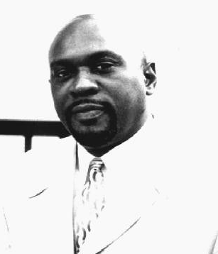

Bishop Victor Powell

Dr. Victor L. Powell serves as senior pastor of Rhema Word International Ministries in Albany, GA. He has led Rhema Word through several ministerial transitions since 1990. In 2003, Rhema purchased 113 acres of land. Dr. Powell’s God-given vision is that this land will be a gathering place for people from all nations to be trained in areas such as ministry, leadership, economic development, and missions. It will also be an oasis for the local community of Albany and the southwest Georgia region. A native of Chicago, IL, Dr. Powell’s leadership credentials include a nine year career in the U.S. Marine Corps., where he was meritoriously promoted up to Staff Sergeant and served as an instructor with the Officers’ Leadership School. Dr. Powell is a certified trainer with the State of Georgia, having served in that capacity with the Department of Corrections and having trained hundreds of law enforcement officers for the State of Georgia. He is the founder of Stand Up Again Outreach, Inc., a ministry that services the local community and several foreign countries, including Ghana and Haiti. Since 1985, Dr. Powell has ministered tirelessly to the hungry, alcoholics, prostitutes, drug addicted and homeless. Regionally, people are impacted weekly by the Word of God through Stand up Again television broadcasts. Internationally, God has used Dr. Powell and Stand up again to serve others by sending missionaries and financial resources to other countries. Dr. Powell is the President and CEO of VLP, Inc., an establishment that provides training and motivational speaking to corporations and agencies. In October 2002, he was consecrated to the office of Bishop by Archbishop Earl Paulk of the International Charismatic Communion of Churches in Decatur, GA. and has served on its College of Bishops. In 2006, he received an Honorary Doctorate degree in Biblical Studies from Midwest Theological Institute of Indiana. A world traveler, Dr. Powell has traveled to Africa, Asia and North America. He currently serves on the Board of Directors for Albany Georgia’s Chamber of Commerce, Apostolic Worship Enterprise and Capitol City Bank. Dr. Powell released his first book, Closet Ministry: The Power of Prayer and the Release of Destiny, in 2003. He has a prophetic and relevant word, teaching empowerment for all people. He is married to the former Sandra F. Smiley and has three adult children.

4

Holy Communion
(The Congregation will remain seated)

Communicant Bishop Frederick J. Wilson

(Organ Prelude) “LET US BREAK BREAD TOGETHER”

The Presentation of the Bishop Bishop G. Warren Manigault II

The Governing Board of Judah Ministries International has assigned to you, as Bishop the following duties:

- To function as the administrative head of the Ecclesiastical Jurisdiction to which you are assigned.

- To seek out and discover, in cooperation with your congregations, a suitable pastor for each
congregation under your care.
- To counsel with these pastors in planning well balanced ministry programs

- To inspire the pastor to spiritual growth and personal improvement for more effective witnessing for Christ and his kingdom. To encourage pastoral visitations in home, hospitals, and penal institutions.

- To stimulate by your life and example as well as by your effective preaching, the outlook and vision of your people and inspire them to holier living and more dedicated devotion to the Lord Jesus Christ and His Church.

- To uphold, obey and defend the constitution, by-laws, doctrine and policy of Judah Ministries International as now is or may be amended from time to time, and to teach the pastors and congregations under your charge to do the same.

- To seek out communities in your Jurisdiction into which a Christian Witness might be effectively carried and other ministry affiliations may be established.

“My brother, in the name of our Lord and Savior Jesus Christ, The Great Head of the Church and by the authority vested in me by the Governing Board of Judah Ministries International, I do hereby install to the office of Bishop for the state of Missouri, USA in the South Central jurisdiction of Judah Ministries International.

Bishop’s Greetings Bishop John D. Birmingham Jr.

Final Blessing and Benediction Bishop G. Warren Manigault II

The Recessional

17
Judah Ministries International

Member Churches
Cathedral of Deliverance World Wide Church | Chain Link Spiritual Temple of Christ
Bishop LeAndrew Tyson | Pastor Dannie Patton
1124 Highland Avenue | 2722 Wabash Avenue
Albany, GA. 31707 –4353 | Kansas City, MO. 64109
Tel: 229-669-8029
bishoptyson_jmi@yahoo.com | Christ-Citadel International Church
 | Evangelist Samuel Nyika
Christ-Citadel International Church | P.O.Box 1077
Pastor James Kaziba | Kampala Uganda
P.O. Box 21407 | Tel: 011-25-677-602336
Kampala Uganda | samuelnyika@hotmail.com
Tel: 011-25-677-602336
cicuganda@yahoo.com | Courts of Joy Ministries
 | Bishop Hollis Peters
The Church of the Living God Life Worship Center | 5 Lachous Road  Penal, Trinidad West Indies
Bishop Vincent Simmons | Tel: 868-647-3532
PO Box 60777  Charleston, SC 29419 | marl_peters@yahoo.com
Tel: 843-745-9700 | Deliverance Through Praise Outreach Ministry
cfmi5@aol.com | Pastor Brandon Gooch
 | 802 Evans Street
Crestar Ministries | Marshall, TX 75670
Pastor Eileen Manswell | Tel: 903-472-1444
Gallery Street | Bishopgooch@yahoo.com
California Trinidad, West Indies
Tel: 868-636-2483 | Emmanuel Healing Center Church
year9110@wasa.gov.tt | Pastor John Magezi
 | P. O. Box 1547
 | Maska, Uganda
 | Tel: 011-25-648-120514
 | jfbmagezi@yahoo.com

18
Judah Ministries International
Conference 2007
“Committed to the Harvest”

Thursday, July 26, 2007 - 7:30 PM

Invocation Prophetess JoAnn Tyson

Scripture Reading First Lady Birmingham

Praise & Worship Cathedral of Deliverance Praise Team– JMI, Albany, GA.

Expediter Pastor Koneoa Williams

Welcome Minister Angel Acquah

Remarks/Ministry in Song Pastor Eric Nesmith
Grace Tabernacle Way of the Cross, Atlanta, GA.

Ministry in Giving JMI Finance Committee

Ministry in Song JMI 2007 Conference Choir

Introduction of Speaker Bishop F. J. Wilson

Ministry in Song Sister Alisa Green
Kingstree, SC

The Word Bishop-Elect John Birmingham
Victory in Praise Revival Center - JMI, Raytown, MO.

Altar Call

Acknowledgments/Announcements Lady Belinda Simmons

Final Remarks / Benediction JMI Bishop

3

The Investiture of the Bishop
(The Congregation will remain seated)

Reading of the Vestments Bishop Gladys Coleman

The Bestowing of Vestments College Of Bishops

Cassock

Cincture

Rochet

Chimere

Tippet

Pectoral Cross

Ring

Cope

Biretta

The Word of God

16
Judah Ministries International
Conference 2007
“Committed to the Harvest”

Friday, July 27, 2007 - 7:30 PM

Invocation Deacon Kingston Acquah

Scripture Reading Pastor Patricia Myricks

Praise & Worship JMI Praise Team

Expediter Brother Ronald Mayes

Welcome Minister Tawana Newkirk

Remarks/Ministry in Song Pastor Darrel Thomas
Love Fellowship Christian Church, College Park, GA.

Remarks/Ministry in Song Bishop Joe T. Gamble
Nesmith WOTCC, Nesmith, SC

Ministry in Song Sister Alisa Green
Kingstree, SC

Ministry in Giving JMI Finance Committee

Ministry in Song JMI 2007 Conference Choir

Introduction of Speaker Bishop LeAndrew Tyson

Ministry in Song Rhema Word International Ministries Choir

The Word Bishop Victor Powell
Rhema Word International Ministries, Albany, GA.
Altar Call

Acknowledgments/Announcements Sister Demetria Johnson-Hill

Final Remarks / Benediction JMI Bishop

5
Judah Ministries International
Conference 2007
“Committed to the Harvest”
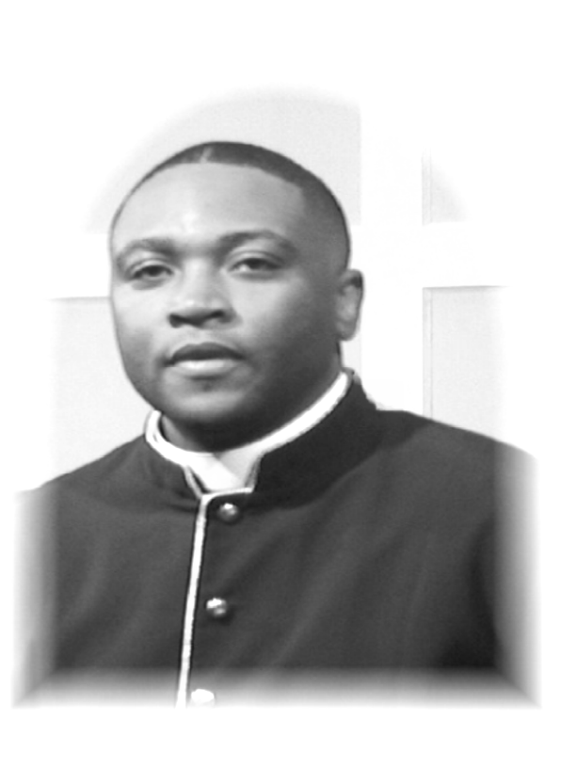

Elder Tracy Boles

Elder Tracy L. Boles is a native of Hampton South Carolina, and the son of Deacon and Mrs. James H. Boles. Elder Boles was licensed to preach the Gospel in 1999 at the Wilkerson Baptist Church in Hampton S.C. He currently resides in Atlanta Ga., with his lovely wife Darlene, their son Tracy James, and their daughter Faith. He and his family are members of the New Beginning Full Gospel Baptist Church, where Elder Boles serves as a personal assistant to Bishop James H. Morton. Elder Boles also serves on the Fellowship Assistance Council for the Full Gospel Baptist Church Fellowship. He is the Southeast Regional Director of Armor Bearers, and the Youth Director for the State of Georgia. He is a 1995 graduate of Lander University, a 1999 graduate of the American Institute of Banking, and is currently pursuing a Masters of Ministry at Trinity Theological Seminary. Before pursuing ministry as his full-time occupation, Elder Boles was a project manager for Bank of America. During his seven years of service he was promoted to the ranks of Assistant Vice President. His motto for life is “The steps of a good man are ordered by the Lord.” All of these things are good to know, but most importantly he is a saved, Bible believing, teacher and preacher.

6

The Consecration of the Bishop

(The Congregation will remain seated)

Consecrator Bishop G. Warren Manigault II

The Pillow Bearer First Lady Birmingham/Adjutant

Prayer of Consecration Bishop G. Warren Manigault II

God and Father of our Lord Jesus Christ, Father of Mercies and God of all comfort, dwelling on High by having regard for the lowly, knowing all things before they come to pass: We give you thanks that from the beginning you have gathered and prepared a people to be heirs of the covenant of Abraham, and have raised up prophets and kings, and priests, never leaving your temple unattended. We praise you also that from creation you have graciously accepted the ministry of those whom you have chosen.

Therefore, Father, make John D. Birmingham, Jr. Bishop in your Church. Pour out upon him the power of your princely Spirit, whom you bestowed upon your beloved Son Jesus Christ, with whom he endowed the apostles, and by whom your Church is built up in every place, to the glory and unceasing praise of your Name.

15

The Inquiry

Bishop: Will you accept this call in obedience to Christ?
Answer: I will obey Christ, and will serve in His name.

Bishop: Will you be faithful in prayer, and in the study of Holy Scripture,
that you will continue to have the mind of Christ?
Answer: I will, for He is my help.

Bishop: Will you boldly proclaim and interpret the Gospel of Christ, enlightening the mind and stirring up the conscience of your people?
Answer: I will, in the power of the Spirit.

Bishop: As a chief elder and pastor, will you encourage and support all baptized believers in their gifts and ministries, nourish them from the riches of God’s grace, pray for them without ceasing, and celebrate with them the sacraments of our redemption?
Answer: I will, in the name of Christ, the Shepherd and Bishop of our souls.

Bishop: Will you guard the faith, unity, and discipline of the Church?
Answer: I will, by the grace of God.

Bishop: Will you share with your fellow Bishops in the government of the whole Church; will you sustain your fellow presbyters and take counsel with them; will you guide and strengthen the diaconate and all others who minister in the church?
Answer: I will, by the grace of God.

Bishop: Will you be merciful to all, show compassion to the poor and strangers, and defend those who have no helper?
Answer: I will, for the sake of Christ who has called me.

14
Judah Ministries International
Conference 2007
“Committed to the Harvest”

Saturday, July 28, 2007 - 6:00 PM

Invocation Minister Charlene Marrow

Scripture Reading Sister Shauna Young

Praise & Worship JMI Youth Praise Team

Expediter Deacon-Elect Lawrence Waters

Welcome Brother David Jordan Jr.

Ministry in Song JMI 2007 Youth Conference Choir

Ministry in Dance HTC Brockton Liturgical Dancers – JMI, Brockton, MA.

Ministry in Gospel Rap God’s Finest
Greater Faith Worship Center Campus - JMI, Hyde Park, MA.

Ministry in Song Springfield Missionary Baptist Church Youth Choir
Atlanta, GA.

Ministry in Giving JMI Finance Committee

Ministry in Dance New Generation
House of Judah Deliverance Center – JMI, Newport News, VA.

Ministry in Song Shields of Faith
Hopewell Baptist Church, Norcross, GA.

Ministry in Dance God’s Anointed
Kingstree, SC

Introduction of Speaker Elder Eric Parks

Ministry in Song New Beginning Full Gospel Baptist Church Choir

The Word Elder Tracy Boles
New Beginning Full Gospel Baptist Church, Decatur, GA.

Altar Call

Acknowledgments/Announcements

Final Remarks / Benediction JMI Bishop

7

Judah Ministries International
Conference 2007
“Committed to the Harvest”
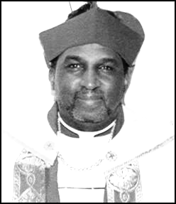

Bishop George W. Manigault, II.

George Warren Manigault, II, was born on December 11, 1950 in Chelsea, MA., growing up with his sisters and brothers in Roxbury and Dorchester. “Warren” accepted the Lord as his personal savior, in his late teens, at the Way of The Cross Holy Church in Dorchester, MA, under the leadership of Pastor E.M. Kelley. It was there that he met the woman he would spend the rest of his life with (Catherine A. McCray) and they were married on January 3, 1970. They are the proud parents of George Warren, III (Julie) and Shekinah Aleah, and loving grandparents of Josiah Warren, Adriannah Marie and Anjolique Mariella.

His ministry flourished and matured at Holy Tabernacle Church in Dorchester under the leadership of the late Bishop Dr. Joe L. Smith. In 1980 he was called into the Gospel Ministry, and was ordained to the office of Elder on January 19, 1982. After serving faithfully as Elder, Musician, and Teacher, he acknowledged the calling on his life to the pastorate. With Bishop Smith’s blessings, Elder Manigault was elevated to the office of Pastor in September 1994. One month later, he along with his family and 8 members from the Holy Tabernacle Dorchester congregation, founded the Holy Tabernacle Church of God In Christ Brockton.

In November 2000 the Lord led Pastor Manigault to contact several former Holy Tabernacle ministers who were pastoring their own churches. Out of these meetings, the fellowship known as Judah Ministries, International. (JMI) was formed in December 2000. In July 2002, Pastor Manigault was elevated again to the office of Bishop. He currently serves as the Presiding Prelate for this God ordained ministry.

Bishop Manigault loves the Lord and is zealous to bring the reverent and relevant message of the Gospel to all that will hear. He strives to live out God’s mandate to “go into all the earth to preach and teach, and make disciples.” He endeavors to serve God with a Spirit of Praise, a Unity of Purpose, and an Unselfish Love.

8

The Scriptures Bishop Hollis Peters

The Old Testament Reading Numbers 27: 15-23

The Reading of the Epistle 1 Timothy 3: 1-7

The Reading of the Gospel St. John 17:17-22

Ministry of Song Judah Ministries Choir

The Examination Bishop G. Warren Manigault II

“My Brother: God has chosen you and the people have affirmed their trust in you by acclaiming your appointment. A Bishop in God’s holy church is called to be one with the apostles in proclaiming Christ’s resurrection, interpreting the Gospel, and testifying to Christ’s sovereignty as Lord of lords and King of kings.

You are called to guard the faith, unity, and discipline of the Church; to celebrate and provide for the administration of the sacraments of the New Covenant; to ordain Elders and Deacons and to join in ordaining Bishops; and to be in all things a faithful Pastor and wholesome example for the entire flock of Christ.

With your fellow Bishops, you will share in the leadership of the Church throughout the world. Your heritage is the faith of patriarchs, prophets, apostles, martyrs, and those of every generation who have looked to God in hope. Your Calvary is to endure the loneliness of the office; to never require approval but exercising your duty to act in the best interest of Christ’s Church. Your joy will be to follow Him who came, not to be served, but to serve, and who gave his life as a ransom for many.

Are you persuaded that God has called you to the office of Bishop?”

Answer: “I am so persuaded.”

13

The Order of Consecration

The Bishop-elect to be Consecrated

John D. Birmingham, Jr.

The Reading of the Testimonial Bishop Sureman Cudjoe

The Presentation Pastor William Birmingham

BISHOP MANIGAULT, The officers and members of the Judah Ministries, trusting in the Divine guidance of the Holy Ghost have chosen John D. Birmingham, Jr. a faithful servant of God, to be ordained Bishop in the Universal Church of Christ.

“We express our confidence in their ability, in his character, and in his devotion to Christ and to the church. We believe that he is capable of directing and promoting the affairs and the interests of the church.”

“We therefore ask you to lay your hands upon him and consecrate him Bishop according to the Word of God.”

The Acceptance Bishop G. Warren Manigault II

“Brothers and sisters in Christ, you have heard the testimony of the officials and members of Judah Ministries. They have expressed their confidence in the Bishop elect ability, character and in their devotion to Christ and the Church. By selecting him to this high calling, they concur that he has the ability to direct and promote the affairs and interest of the church according to the will of God.”

“It is their belief that Pastor, John D. Birmingham Jr. has been ordained by God and chosen by him to serve as a Bishop of Judah Ministries International.”

Bishop: “Is it your will that we consecrate John D. Birmingham Jr. as Bishop?”
People: “That is our will.”
Bishop: “Are you willing to uphold John D. Birmingham Jr. as Bishop?”
People: We will by the grace of God”

12
Judah Ministries International
Conference 2007
“Committed to the Harvest”

Sunday, July 29, 2007 - 11:00 AM

Invocation Bishop Gladys Coleman

Scripture Reading Bishop Shureman Cudjoe

Praise & Worship JMI Praise Team

Expediter Bishop T. Vincent Simmons

Ministry in Song JMI 2007 Conference Choir

Ministry in Giving JMI Finance Committee

Introduction of Speaker Bishop F. J. Wilson

Ministry in Song Sister Alisa Green
Kingstree, SC

The Word Bishop George W. Manigault, II
Presiding Prelate

Altar Call

Consecration Bishop George W. Manigault II

Holy Communion Officiate

Acknowledgments & Announcements Pastor Catherine McCray-Manigault

Final Remarks Bishop George W. Manigault, II

9

Responsive Reading Bishop LeAndrew Tyson

SONG OF CELEBRATION - Psalm 95: 1-7, 96: 1-6

Leader: O come, let us sing unto the LORD:
Let us make a joyful noise to the rock of our salvation.

People: Let us come before his presence with thanksgiving,
And make a joyful noise unto him with psalms.

Leader: For the LORD is a great God, and a great King above all gods.

People: In his hand are the deep places of the earth: the strength of the hills is his also.

Leader: The sea is his, and he made it: and his hands formed the dry land.

People: O come, let us worship and bow down: let us kneel before the LORD our maker.

Leader For he is our God; and we are the people of his pasture, and the
sheep of his hand.

People O sing unto the LORD a new song: sing unto the LORD, all the earth.

Leader Sing unto the LORD, bless his name; shew forth his salvation from day
to day.

People: Declare his glory among the heathen, his wonders among all people.

Leader: For the LORD is great, and greatly to be praised: he is to be feared
above all gods.

People: For all the gods of the nations are idols: but the LORD made the
heavens.

Leader: Honor and majesty are before him: strength and beauty are in his
Sanctuary.

11

Preface to the Service Bishop T. Vincent Simmons

Since the days of the apostles and throughout the Scriptures, God has used sacred offices and ministries to guide the Church to the fulfillment of its earthly purpose. The earliest records of ancient Christian writers have included Holy rituals that have given the Christian Church its character and majesty. The Old and New Testaments contain depictions of God’s design and relationship to the Church. The New Testament in particular, gives fine points that outline the character and duties of the post-Resurrection Church. The Scriptural models highlight the orders of ordained ministries that give expression to the character of the Christian Church. The New Testament Scriptures and Book of Common Prayer outline the use and purpose of these sacred offices. The orders of Bishops are those who are called to lead, oversee and unite the Church. They guide and teach others to fulfill Christ’s Commission in the world. The Presbyters or Elders are charged to govern, shepherd, proclaim the Gospel, administer the Lord’s ordinances and strengthen the Church missionary zeal. The Diaconate or Deacons assist the Bishops and Pastors in all areas of the ministry, which also includes ministry to the sick, poor and disenfranchised.

The Church recognizes those who are capable and called of God to ordain them to the work of the ministry. Their ability and gifting is acknowledged through ceremonial prayer and the laying on of hands. Those who are called are forever associated with the redemptive plan of God for peace and reconciliation in the world. The act of consecration is a public affirmation of the servant’s call and pledge of lifelong commitment to the cause of Christ and the Church.

The chronicles of these ancient offices date back to the first century. Each bishop receives his consecration through the laying on of hands. This act confers upon the recipient the history and purpose of the office. Bishops are consecrated by other Bishops who are qualified to confer upon the recipient the rights and responsibilities of the office. This threefold ministry is a blessing from God for the edifying, nurturing and sharing of the Gospel throughout the world. Those whom God calls are publicly set apart by Him, for a special work hence our Bishop elect John D. Birmingham Jr. joins a long-standing tradition of those called to serve the greater Church. This is the reason that we have gathered here today.

10

