NOTES:  12 | Judah Ministries International  Conference 2007  “Committed to the Harvest”  *CONFERENCE OUTLINE  Thursday, July 26, 2007 – Arrival Day  - 11:00 am Registration  1:00 pm “Stir Up The Gifts”  - 7:30 pm Evening Worship  Speaker: Bishop-Elect John Birmingham  Victory in Praise Revival Center, JMI  Raytown, MO.  Friday, July 27, 2007 – Day 2  - 7:00 am Early Morning Glory  - 9:00 am “Word From the Sowers”  1:00 pm  - 7:30 pm Evening Worship  Speaker: Bishop Victor Powell  Rhema Word International Ministries  Albany, GA.  Saturday, July 28, 2007 – Day 3  - 8:30 am Early Morning Glory  - 6:30 pm “Youth Explosion”  Speaker: Elder Tracy Boles  New Beginning Full Gospel Baptist Church  Decatur, GA.  Sunday, July 29, 2007 – Day 4  - 9:00 am Christian Learning School,  Supt., Minister David Jordan  - 11:30 am Morning Worship  Speaker: Bishop George W. Manigault, II, Presiding Prelate  Communion & Consecration Service  Bishop-Elect John Birmingham  *Program subject to change  1

`

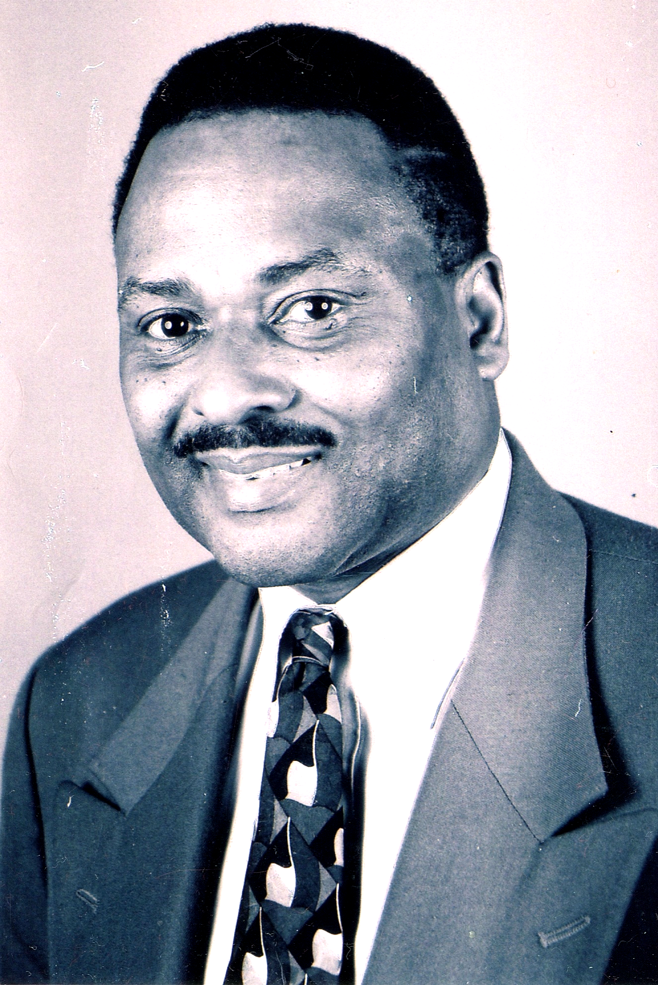
Judah Ministries International
Conference 2007
“Committed to the Harvest”

Bishop-elect John D. Birmingham Jr.
Bishop–elect John D. Birmingham Jr. was born in Kansas City, Missouri. He is the eldest of twenty-four children. Educated in the Kansas City (MO) School District, he went on to attend Western Bible Seminary and Faith Bible College. He has a Doctorate degree in Theology and Christian Education, as well as a degree in Christian Counseling. He confessed his faith in Christ Jesus at tem and became a young deacon. Deacon Birmingham accepted his call to the ministry when he was 21 years old under the late Rev. Charles Wheeler III at Westminster Baptist Church. Rev. Birmingham’s first charge was at Second Baptist Church in St. Louis, MO. He served as a pastor in Hugo, OK and is currently the pastor of Victory in Praise Revival Center in Raytown, MO. He is also Chancellor of Harvest Reapers Bible College (FBC) in Raytown, MO During the 1970s and late 1980s, Bishop–elect Birmingham made an impact in the Kansas City area via The Upper Room Compassionate Ministry. This ministry was located on the North end of Troost Avenue in an area known as the “Red Zone.” This area was infamous for pimps, prostitution, drug pushers, pornography shops, strip bars, and gay establishments. God used Bishop-elect Birmingham to clean up Troost Avenue in a way that local law enforcement could not. The move of God was so overwhelming that the mayor named him Chaplain of Troost. He was also featured on the 700 Club with Pat Robertson. Bishop-elect Birmingham has held revivals and crusades from as far as Jamaica and Haiti to the outskirts of our Southern states. What is dear to his heart, year after year, is helping the community by preaching the Gospel to save souls, feeding the hungry, and clothing the less fortunate. In the late 1970s, he wrote a play entitled Soul Free, which aired on a local television station. He is also the author of several books: Chaplain of the Troost, Young Black Men An Endangered Species, Slipping of the Shepherds and the latest Take it to the Streets. Bishop-elect Birmingham is a true humanitarian of his own kind. He has one son, Kenneth Steele, who is also in the ministry.

2

Judah Ministries International

Member Churches (continued)
Holy Tabernacle Church #2 | Holy Tabernacle Church of Brockton
Pastor Naomi Witherow | Bishop G. Warren Manigault II
8221 Old Cleveland Pike | Pastor Cathy McCray-Manigault
Ooltewah, TN 37363 | 861 Main Street
Tel: 423-892-8441 | Brockton, MA 02301
Nwitherow@aol.com | Tel: 508-584-2069
 | bishop@holytabernacleministries.org
House of Judah Deliverance Center | Jesus Is The Rock Ministries
Pastor Gladys E. Coleman | Pastor Darlene Dixon
P. O. Box 231 | 8618 E. Utopia #54B
Newport News, VA 23607 | Raytown, MO 64138
Tel: 757-247-0229 | Tel: 816-353-1973
bishopcoleman@churchnetworks.org

Judah, Inc. | Mount Olive Non-Denominational Church
Pastor Michael & Sharron Craddock | Pastor Konoea Williams
8126 Sterling Avenue | 2311 Habersham Road
Raytown MO, 64138 | Albany, GA 31701
Tel: 816-694-6174 | Tel: 229-679-5746
drsmascradd@hotmail.com | KonoeaW2002@yahoo.com
Refuge and Relief Ministry, Inc. | St. John House of Bread Ministries
Pastor Lorraine Lopes | Bishop-elect Cudjoe Shureman
P.O. Box 024189 | 55 Porforce Ext
Boston, MA 02124 | Gasparillo Trinidad, West Indies
Tel: 617-282-0231 | Tel: 868-650-4909
revlopes@comcast.net | cudjoe@hotmail.com
The Friends Of God Global Outreach | True Gospel Church Of God In Christ
Apostle John B. Baley, Sr. | Pastor Alice Roberson
40 Oak Hill Cluster | 4306 Troost Avenue
Independence, MO 64057 | Kansas City, MO 64109
Tel: 816-228-3634  WarriorSpirit777@aol.com | Tel: 816-531-4411
Victory In Praise Revival Center
Bishop elect John Birmingham Jr.
 | 9140 E. 350 Hwy.
 | Raytown, MO 64133
 | Tel: 816-356-3884

11

Judah Ministries International
Conference 2007
“Committed to the Harvest”

Bishop Victor Powell
Dr. Victor L. Powell serves as senior pastor of Rhema Word International Ministries in Albany, GA. He has led Rhema Word through several ministerial transitions since 1990. In 2003, Rhema purchased 113 acres of land. Dr. Powell’s God-given vision is that this land will be a gathering place for people from all nations to be trained in areas such as ministry, leadership, economic development, and missions. It will also be an oasis for the local community of Albany and the southwest Georgia region. A native of Chicago, IL, Dr. Powell’s leadership credentials include a nine year career in the U.S. Marine Corps., where he was meritoriously promoted up to Staff Sergeant and served as an instructor with the Officers’ Leadership School. Dr. Powell is a certified trainer with the State of Georgia, having served in that capacity with the Department of Corrections and having trained hundreds of law enforcement officers for the State of Georgia. He is the founder of Stand Up Again Outreach, Inc., a ministry that services the local community and several foreign countries, including Ghana and Haiti. Since 1985, Dr. Powell has ministered tirelessly to the hungry, alcoholics, prostitutes, drug addicted and homeless. Regionally, people are impacted weekly by the Word of God through Stand up Again television broadcasts. Internationally, God has used Dr. Powell and Stand Up Again to serve others by sending missionaries and financial resources to other countries. Dr. Powell is the President and CEO of VLP, Inc., an establishment that provides training and motivational speaking to corporations and agencies. In October 2002, he was consecrated to the office of Bishop by Archbishop Earl Paulk of the International Charismatic Communion of Churches in Decatur, GA. and has served on its College of Bishops. In 2006, he received an Honorary Doctorate degree in Biblical Studies from Midwest Theological Institute of Indiana. A world traveler, Dr. Powell has traveled to Africa, Asia and North America. He currently serves on the Board of Directors for Albany Georgia’s Chamber of Commerce, Apostolic Worship Enterprise and Capitol City Bank. Dr. Powell released his first book, Closet Ministry: The Power of Prayer and the Release of Destiny, in 2003. He has a prophetic and relevant word, teaching empowerment for all people. He is married to the former Sandra F. Smiley and has three adult children.

4

4

6
Judah Ministries International
Conference 2007
“Committed to the Harvest”

Sunday, July 29, 2007 - 11:00 AM

Invocation Bishop Gladys Coleman

Scripture Reading Bishop Cudjoe Shureman

Praise & Worship JMI Praise Team

Expediter Bishop Vincent Simmons

Ministry in Song JMI 2007 Conference Choir

Ministry in Giving Pastor Ruth e Wilson

Holy Communion Bishop F. J. Wilson

Introduction of Speaker Bishop F. J. Wilson

Ministry in Song JMI 2007 Conference Choir

The Word Bishop George W. Manigault, II
Presiding Prelate

Altar Call

Consecration & Holy
Communion Service Bishop George W. Manigault II
Officiant
Final Remarks / Benediction

9

4

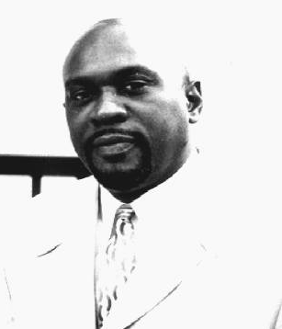

Judah Ministries International
Conference 2007
“Committed to the Harvest”

Thursday, July 26, 2007 - 7:30 PM

Invocation Evangelist Virginia Strong

Scripture Reading Lady Belinda Simmons

Praise & Worship JMI Praise Team

Expediter

Remarks/Ministry in Song Pastor Eric Nesmith
Grace Tabernacle Way of the Cross
Atlanta, GA.

Ministry in Giving Pastor Ruth e Wilson

Introduction of Speaker Bishop F. J. Wilson

Ministry in Song JMI 2007 Conference Choir

The Word Bishop-Elect John Birmingham
Victory in Praise Revival Center, JMI
Raytown, MO.

Altar Call

Acknowledgments/Announcements Lady Belinda Simmons

Final Remarks / Benediction JMI Bishop

3

4
Judah Ministries International

Member Churches
Cathedral of Deliverance World Wide Church | Chain Link Spiritual Temple of Christ
Bishop LeAndrew Tyson | Pastor Dannie Patton
1124 Highland Avenue | 2722 Wabash Avenue
Albany, GA. 31707 –4353 | Kansas City, MO. 64109
Tel: 229-669-8029
bishoptyson_jmi@yahoo.com | Christ-Citadel International Church
 | Evangelist Samuel Nyika
Christ-Citadel International Church | P.O.Box 1077
Pastor James Kaziba | Kampala Uganda
P.O. Box 21407 | Tel: 011-25-677-602336
Kampala Uganda | samuelnyika@hotmail.com
Tel: 011-25-677-602336
cicuganda@yahoo.com | Courts of Joy Ministries
 | Bishop Hollis Peters
Church of The Living God Worship Center | 5 Lachous Road  Penal, Trinidad West Indies
Bishop Vincent Simmons | Tel: 868-647-3532
4744 Rivers Avenue | marl_peters@yahoo.com
North Charleston, SC 29419  Tel: 843-745-9700 | Deliverance Through Praise Outreach Ministry
cfmi5@aol.com | Pastor Brandon Gooch
 | 802 Evans Street
Crestar Ministries | Marshall, TX 75670
Pastor Eileen Manswell | Tel: 903-472-1444
Gallery Street | Bishopgooch@yahoo.com
California Trinidad, West Indies
Tel: 868-636-2483 | Emmanuel Healing Center Church
year9110@wasa.gov.tt | Pastor John Magezi
 | P. O. Box 1547
Faith Apostolic Church of Jesus Christ | Maska, Uganda
Pastor Patricia Myricks | Tel: 011-25-648-120514
5 Barclay Court | jfbmagezi@yahoo.com
Rochester, NY 14612
 | Greater Faith Worship Center Campus
 | Bishop F. J. Wilson
 | Pastor Ruth e Wilson
 | 120 Safford Street
 | P.O. Box 365684
 | Hyde Park, MA 02136
 | Tel: 617-361-5479
 | gfwcc@verizon.net

10

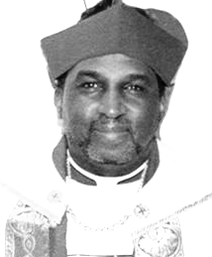
Judah Ministries International
Conference 2007
“Committed to the Harvest”

Bishop George W. Manigault, II.
George Warren Manigault, II, was born on December 11, 1950 in Chelsea, MA., growing up with his sisters and brothers in Roxbury and Dorchester. “Warren” accepted the Lord as his personal savior, in his late teens, at the Way of The Cross Holy Church in Dorchester, MA, under the leadership of Pastor E.M. Kelley. It was there that he met the woman he would spend the rest of his life with (Catherine A. McCray) and they were married on January 3, 1970. They are the proud parents of George Warren, III (Julie) and Shekinah Aleah, and loving grandparents of Josiah Warren, Adriannah Marie and Anjolique Mariella.
His ministry flourished and matured at Holy Tabernacle Church in Dorchester under the leadership of the late Bishop Dr. Joe L. Smith. In 1980 he was called into the Gospel Ministry, and was ordained to the office of Elder on January 19, 1982. After serving faithfully as Elder, Musician, and Teacher, he acknowledged the calling on his life to the pastorate. With Bishop Smith’s blessings, Elder Manigault was elevated to the office of Pastor in September 1994. One month later, he along with his family and 8 members from the Holy Tabernacle Dorchester congregation, founded the Holy Tabernacle Church of God In Christ Brockton.
In November 2000 the Lord led Pastor Manigault to contact several former Holy Tabernacle ministers who were pastoring their own churches. Out of these meetings, the fellowship known as Judah Ministries, International. (JMI) was formed in December 2000. In July 2002, Pastor Manigault was elevated again to the office of Bishop. He currently serves as the Presiding Prelate for this God ordained ministry.
Bishop Manigault loves the Lord and is zealous to bring the reverent and relevant message of the Gospel to all that will hear. He strives to live out God’s mandate to “go into all the earth to preach and teach, and make disciples.” He endeavors to serve God with a Spirit of Praise, a Unity of Purpose, and an Unselfish Love.

8
Judah Ministries International
Conference 2007
“Committed to the Harvest”

Friday, July 27, 2007 - 7:30 PM

Invocation Pastor Konoea Williams

Scripture Reading Pastor Patricia Myricks

Praise & Worship JMI Praise Team

Expediter

Remarks/Ministry in Song Pastor Darrel Thomas
Love Fellowship Christian Church
College Park, GA.

Remarks/Ministry in Song Bishop Mary Lawrence
Open Door Outreach Center, Inc., Atlanta, GA.

Ministry in Giving Pastor Ruth e Wilson

Introduction of Speaker Bishop LeAndrew Tyson

Ministry in Song JMI 2007 Conference Choir

The Word Bishop Victor Powell
Rhema Word International Ministries
Albany, GA.

Altar Call

Acknowledgments/Announcements

Final Remarks / Benediction JMI Bishop

5

4
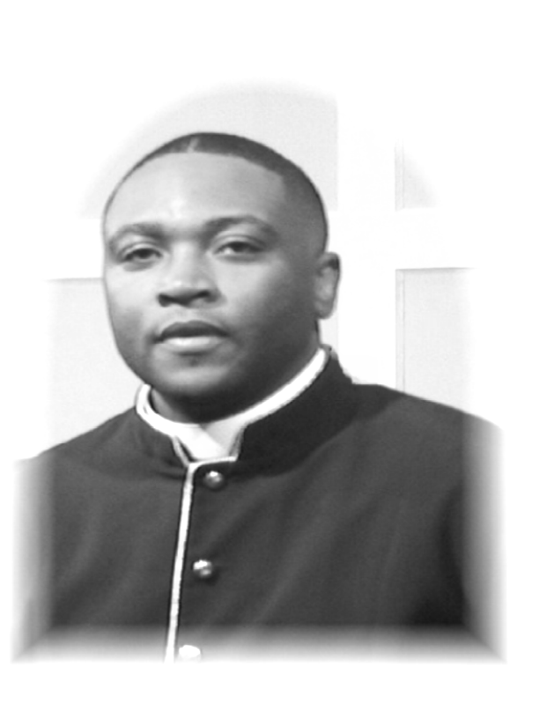
Judah Ministries International
Conference 2007
“Committed to the Harvest”

Saturday, July 28, 2007 - 6:30 PM

Invocation

Scripture Reading

Praise & Worship JMI Youth Praise Team

Expediter

Ministry in Song JMI 2007 Youth Conference Choir

Ministry in Dance

Ministry in Song

Ministry in Gospel Rap

Ministry in Giving Pastor Ruth e Wilson

Ministry in Dance

Introduction of Speaker

Ministry in Song

The Word Elder Tracy Boles
New Beginning Full Gospel Baptist Church
Decatur, GA.

Altar Call

Acknowledgments/Announcements

Final Remarks / Benediction JMI Bishop

7

.

4
Judah Ministries International
Conference 2007
“Committed to the Harvest”

Elder Tracy Boles
Elder Tracy L. Boles is a native of Hampton South Carolina, and the son of Deacon and Mrs. James H. Boles. Elder Boles was licensed to preach the Gospel in 1999 at the Wilkerson Baptist Church in Hampton S.C. He currently resides in Atlanta Ga., with his lovely wife Darlene, their son Tracy James, and their daughter Faith. He and his family are members of the New Beginning Full Gospel Baptist Church, where Elder Boles serves as a personal assistant to Bishop James H. Morton. Elder Boles also serves on the Fellowship Assistance Council for the Full Gospel Baptist Church Fellowship. He is the Southeast Regional Director of Armor Bearers, and the Youth Director for the State of Georgia. He is a 1995 graduate of Lander University, a 1999 graduate of the American Institute of Banking, and is currently pursuing a Masters of Ministry at Trinity Theological Seminary. Before pursuing ministry as his full-time occupation, Elder Boles was a project manager for Bank of America. During his seven years of service he was promoted to the ranks of Assistant Vice President. His motto for life is “The steps of a good man are ordered by the Lord.” All of these things are good to know, but most importantly he is a saved, Bible believing, teacher and preacher.

6

6

